FLOW CHART

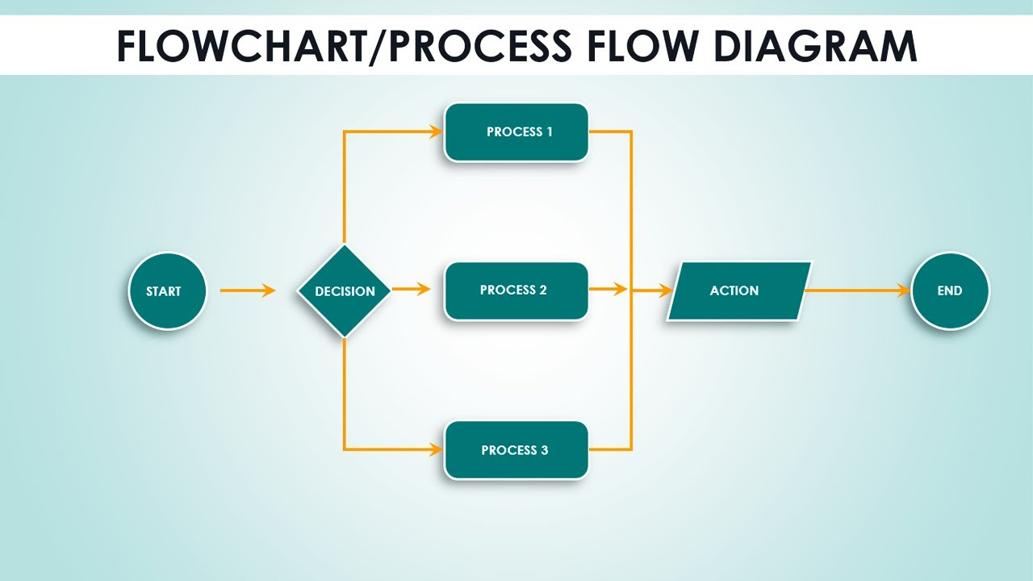

STOP

Display N3

N3 = N1 + N2

Input:- N1,N2, N3

:-

N1, N2, N3

START